Effect Of Monetary Policy On Indian Economy
Yash Sonkar ,
Student , Indore Institute Of law

Abstract
The objective of this research paper is to investigate the impact of monetary policy on Indian economy and analysis of monetary policy. Monetary Policy is a Policy made by the central bank (RBI) to control money supply in the economy and thereby to fight both inflation and deflation. It helps maintain price stability and achieve high economic growth. To Combat Inflation RBI reduces Money Supply (Tight/Dear Money Policy). To Combat Deflation RBI increases Money Supply (Easy/Cheap Money Policy). There are certain quantitative and qualitative tools of monetary policy adopted to achieve specified goals. This paper tries to study all the tools and critically analyse their impact on the growth of the Indian economy. The objectives and the various issues concerned with this policy, their indicators and targets are being succinctly discussed here.

KEYWORDS: Inflation, deflation, Monetary policy ,Money, Economic growth Development of economy
Introduction
By monetary policy, we mean policy concerned with changes in the supply of money. Issues connected with monetary policy are: objectives or goals of the policy, instruments of monetary control, its efficacy, implementation, intermediate target of the policy etc. India ‘s monetary policy since the first plan period was one of 'controlled expansion-that is, a policy of adequate financing of economic growth ensuring reasonable price stability. Thus, RBI helped the economy to expand via expansion of money and credit and attempted to check rise in prices through monetary and other control measures.

A mild version of the liberalization process in the Indian economy was initiated in the mid-1980s. But it lacked depth, coverage and self-sustaining character. During the fag end of the 1980‘s the economy suffered a big jolt with the eruption of a major macro-economic crisis. It manifested initially in the form of foreign exchange crisis, and then debt and interest payment problems. To meet the crisis India approached the World Bank and the International Monetary Fund (IMF) for a big loan. For granting the loan, World Bank and the IMF stipulated certain conditions. Since India was in a critical situation, she accepted the conditions of the World Bank and the IMF and then provided an immediate context for the realignment of the macro-economic fundamentals, through a programme of economic stabilization. With this end in view, India initiated the new economic policy in July 1991.

The package of economic reforms, which are expected to have long-term impact on the economy, includes fiscal, monetary, financial, and industrial and export-import (EXIM)sector reforms. The reforms in monetary and credit policies aimed at slowing down monetary expansion and thereby controlling inflation. The financial sector reforms were initiated on the recommendations of Narasimhan Committee Report. The first phase of reform started with a reduction of Statutory Liquidity Ratio (SLR) and Cash Reserve Ratio (CRR)and permitted a degree of flexibility to the banks in the matter of deposit interest rates
Literature Review

Paulson (1989) studies the effect of monetary policy on the Indian economy during the time leading up to the reform. The study shows that reserve money is the only significant factor affecting the money supply in the economy. He points out the positive connection between inflationary pressures and controlled prices, and what is important, he suggests, is a cordial and symbiotic relationship between monetary policy and fiscal policy in order to maintain price stability.

Arun Ghosh (1994) commented on the interest rate objection should not mean that all interest rates should be brought down abruptly and precipitously. Two steps are, rather, required. The first is a progressive decrease in the structure of the interest rate. Secondly, and more significantly, the establishment of an institutional system that would make available adequate and timely credit to small farmers, small industries, artisans, etc.

Bank for International Settlements (2003) reviewed monetary policy should respond to fluctuations in asset prices and/or financial imbalances beyond their effect on the outlook for inflation. It concludes that, while monetary policymakers are likely to be aware of such trends, the macroeconomic consequences can be adequately addressed within an adequately flexible and forward-looking definition of inflation targets.

Tara pore (1993) elaborated inflation on the poorer parts of society as a levy. It is also argued that the need for monetary relaxation is advantageous to the poorest segments of society. There could be nothing farther from the facts. Inflation mitigation is the strongest anti-poverty initiative for me, and so a robust anti-inflationary monetary policy is in line with public concerns. It also forecasts that, for the near future, the inevitable changes in the stock market would entail the development of entirely new skills in the Reserve Bank, the commercial banks and the financial institutions.

Rangarajan (1996) commended on study conducted by the ASCI during a lecture on Certain Monetary Policy Problems. In fact, many writers conclude that inflation is endemic in the course of economic growth and inflation is viewed more as a monetary phenomenon than as a systemic imbalance, he noted. Due to the need to provide specific guidance to monetary policy makers, the objective question has become relevant.
Tools To Regulate Monetary Policy
There are two tools to regulate monetary policy qualitative and quantitative. With these tools money supply is regulated in the market
Policy Rates- The policy rate includes repo rate, the value wherein the RBI lends banks cash for a short-term period. Then, next is, reverse repo rate, borrowing rate for shorter period at which RBI borrows money from banks. The Reverse Repo rate indicates the rate wherein the reserve bank penetrates the bank liquidity. Then bank rate, the interest rate paid by the RBI for supplying the banking system with funds or loans. Marginal Standing facility, is a special window for banks to borrow from RBI against approved government securities in an emergency like an acute cash shortage
Reserve Ratios- The reserve ratio includes, Cash Reserve Ratio, is minimum ratio stipulated by the RBI. This tool is used by RBI to control liquidity in the banking system. Then, the minimum share of their net demand and time liabilities as liquid assets in the form of cash, gold and accepted securities is the statutory liquidity ratio. Lastly, Open market Operations, in which central bank, in order to extend or contract the sum of capital in the financial system, B. buys and sells government securities on the open market. Country ’s financial system has been one of managed transformation since the first plan era, i.e., a strategy of effective growth financing maintaining fair sustainable growth. Thus, RBI allows the industry grow through money expansion and tried to contain price inflation through monetary and other control measures. This becomes necessary to note that no single arm of economic policy can successfully pursue all the goals. Therefore, there is always the issue of granting the most suitable aim or goal to each mechanism. It is evident from both the empirical evidence and the research findings that monetary policy is ideally suited to achieving the goal of price stability in the economy between different policy objectives.
. Objectives of the Study-
The objectives of the research is to know about the monetary policy and how central bank manages the monetary policy frameworks.
1. To examine the effectiveness of monetary policy in India.
2. To analyse the impact of selected monetary instruments on Indian Economy. C. Hypothesis
H0- The variables are not having any significant effect on GDP of Indian Economy
H1- The variables chosen are having significant effect on GDP of Indian Economy D.
Type of Research- Empirical research is used for analysing the data.
E. Sample Size- 10 years data is collected to analyse the impact of selected variables on Indian Economy.
F. Sampling Technique- Convenient sampling
G. Methods of Data Collection-Secondary-based research. RBI Bulletin, RBI Occasional Articles, RBI Annual Reports, Currency and Finance Report, Economic Survey, Economic and Political Weekly (EPW), Finance and Growth, Economic Diary, The Hindu, ICSSR, Economic Times, IMF Report, Indian Economic Journal, Financial Express, World Bank Reports, Internet, etc., have collected data.
H. Statistical Tool Used- SPSS and MS Excel

Analysis Of Effectiveness Of Monetary Policy In India
1.Gross domestic product
GDP growth rate declined to 6.72% in 2008-09 due to global financial meltdown and improved to 8.59% in 2009-10 and 8.91% in 2010-11 due to high capital inflows. Then again, it slumped to 6.69% in 2011-12, 4.47% in 2012-13 and 4.74% in 2013-14due to domestic policy logjam and tax disputes. India's Index of Industrial Production (IIP) has declined from 5.6 per cent YoY in June 2014 to2.95 per cent in June 2019 quarter. Since demonetization, IIP has dropped by 1.54 per cent. India's fiscal deficit forecast to 3.6 per cent of the GDP for this fiscal year, from 3.4 per cent previously, due to weak revenue
2. Inflation
Wholesale prices of all commodities have risen by about 38% between 2005 and 2010, but prices of food items have jumped by over 77%. Some food items have seen even bigger hikes like vegetables (101%) of milk, eggs, meat and fish (80%). In 2009-2010 the country faced worst situation in food inflation which was the major cause overall inflation. Indian food inflation plunged sharply to 4.3% for the week ended December 2015 as compared to 8 % in the previous months as onions, potatoes and wheat became cheaper and the rise in the prices of other items moderated on the back of a good monsoon. Inflation has dropped sharply in the last four weeks. It had come down in single digit for the week ended November 2012 from 12.21%. The headline inflation based on the wholesale price index was recorded at 9.73%. The Reserve Bank of India (RBI) has hiked key policy rates 13 times since the beginning of 2010 to control the price rise.

3. Foreign Direct Investment
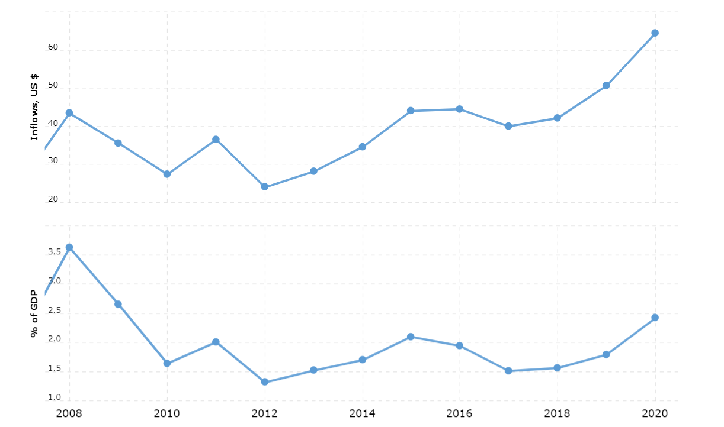
The year 2009, FDI went down by 35.6% and in 2010 it went down by 6.75%.In the year 2011 FDI went up by 31.56%and again in 2012 it went down and the reason for that is Indian economy experienced its slowest growth (GDP drop down to 5.5) and also struggled with risks related to high inflation as a result, investor confidence was affected, and FDI inflows to India declined significantly. But after 2013 it kept on increasing till 2016 and the reason for increase in FDI was MAKE IN INDIA campaign. FDI in India increased by 91% in 4 years of 2013 to 2016.

4. Unemployment rate
The year 2008 is a year of financial crisis and in 2009 economy starts becoming stable then employment rate is also increasing. Later then, poor monsoon hits and there was downfall in employment and in 2010 and 2011 employment rate went down to 3.54. 2012 is the year when periodic employment is there. Then, FDI is initiated in India and it creates more opportunities for employment and employment rate reached to 6.1 in the year of 2018.
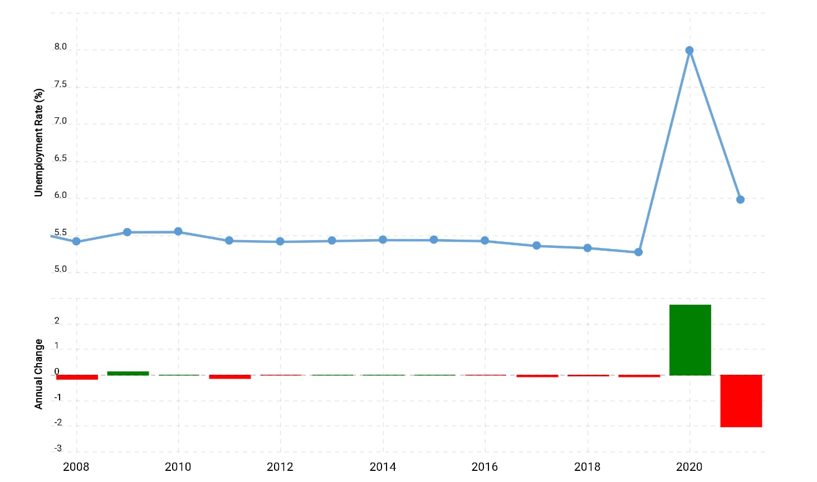

5.Policy Rates
Repo Rate and Reverse Repo Rate is 8 and 14 respectively in 2008 and when recession hits the economy then Indian government decides to control the economy and decreases the rates to 5.8 and 9.8 in 2009. After that it became 6 and 10.2 and this trend keeps following itself till 2012 and in the year of 2012 the rates was 8.2 and 16 and in 2013 the rates became 7.1 and 13.8. Then, in the year of 2017 it came down to 6 and 11 and in 2017 when economy is suffering from Demonetization and GST also came in action so to control the flow of money in economy again government decides to increase the rates and in result of that rates didn’t go down in that year and remain stable at 6 and 11.

Vii. Results And Findings Of The Study
To preview the results, strong evidence was found that monetary policy has systematic adverse effects on a country' s competitiveness, as reflected in a decline of unemployment rate. The study concludes that monetary policy matters for growth both in the short-run and long-run. This study focuses on the evaluation of monetary policy and its impact on Indian economy. The study is done using various indicators and factors such as Gross domestic product as dependent variable and repo rate, reverse repo rate, unemployment, Foreign direct investment and inflation as independent variable. Using these variables, we found out that the economy of a nation is totally dependent on these factors. Indian economy was shaken during the global financial crisis of 2008. Central bank policy rates were slashed to historic laws. There was fiscal deficit, but the economy improved during 2010- 11 and further year. Political instability has also key role on Indian economy the two political giants i.e. congress and BJP has also lot to do with the economy. We witnessed the change in economy of during the regime of both political parties. The parameter of calculating GDP was different. The country also witnessed Demonetization in 2016 which also impacted on the Indian economy. India’s fiscal deficit grown every year after 2014
Viii. Recommendations
A possible offset to the beneficial effects of monetary policy, using a methodology that exploits within-country variation in growth to get a more powerful test of the phenomenon. Literature has demonstrated that achieving higher economic growth must be the priority of Indian monetary policy. The nature of monetary policy in India is circumscribed by the fact that financial market liberalization is far from complete (so that the transmission channel of interest rates is incomplete). The financial structure still has strong monopoly features and an overwhelming stake in the banking sector is held by the government (Sharma 2004). The study also argued that, in order to engineer higher economic growth, such monetary policy should be followed to maintain steady interest and inflation rates. The policy has led to the emergence of substantial capital inflows with attendant large build-up of reserves.
Conclusion
India's GDP is a mixture of all the differential variables that contribute to the Indian economy's well-being. India's GDP provides us with a consolidated report on the Indian economy's results. The two approaches for estimating Indian Gross Domestic Product are the 'Cost Factor' or 'Real Price' approach. The opening-up of the Indian economy was the key factor that led to India's GDP growth after and until the 1990s. Markets were unlocked, and private investments were leveraged by the government. As a consequence, more money has poured into the markets. Laws relating to monetary policy may be active or passive. The passive rule is to keep the supply of capital steady, which is reminiscent of the money growth rule of Milton Friedman. The second, called the rule of price stability, is to adjust the supply of money to maintain the price level stable in response to increases in aggregate supply or demand. Holding the price level and therefore inflation in check is the concept of an active regulation. This rule in India dominates our monetary policy. A stable development is healthy progress.

